

From Discovery to Enterprise Knowledge Management
The Build Roadmap
How the Discovery & Requirements Capture workbook becomes the enterprise knowledge management capability
Enterprise Knowledge Management Programme | August 2026

Contents
Page numbers refresh when the document opens (or right-click > Update Field).

1. The logic: capture what exists, then build what lasts
2. How each discovery module feeds the capability
3. What the enterprise KM capability consists of
4. The build sequence
5. Governance and ownership
6. Measuring success
7. Risks and how this approach handles them
8. The road beyond: AI enablement

1. The logic: capture what exists, then build what lasts
Knowledge management programs most often fail in one of two ways: they build a repository nobody uses, or they buy a tool before understanding what knowledge actually exists and how it flows. Both failures come from designing before inventorying.
This programme inverts that order. The Discovery & Requirements Capture workbook first documents the reality on the ground: the business already runs lookbacks, backcasts, post-audits, maturity assessments, and recurring CI reporting — each producing findings, decision rationales, and recommendations. That existing output is the raw material of the enterprise knowledge management capability. The discovery work tells us what it is, where it lives, what it is used for, where it leaks away, and what the business needs the future capability to do.
The build then proceeds component by component, each one grounded in captured evidence rather than assumption — and sequenced so that value appears early (better findability and protected know-how) while the deeper changes (verified follow-up flows, sustained governance) are put in place deliberately.
Principle — Guiding principle throughout: decisions change when knowledge reaches them. The capability succeeds when a past lesson changes a plan, a procedure, or a decision — not when a repository fills up.

2. How each discovery module feeds the capability
Nothing captured during discovery is wasted. Each module's output maps directly to a component of the future capability:
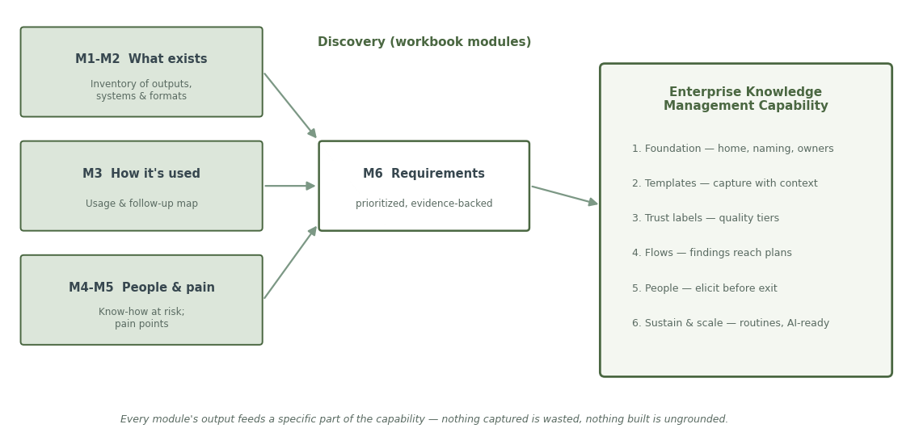
Discovery output (workbook module) | What it becomes in the build
M1 — Inventory of what's produced (items, formats, owners, condition, findability) | The migration and onboarding list: what moves into the managed home, in what priority order; the naming and metadata standard applied to each class of item
M2 — Systems & formats landscape | The integration and access map: which systems the capability must connect to or replace, and where content stays in place under management
M3 — Usage & follow-up map (what happens next, verification) | The capture templates (what context must be recorded at creation) and the follow-up workflows that route findings to plans, procedures, and decisions
M4 — People & know-how at risk | The elicitation programme: who gets interviewed or shadowed first, and the format their knowledge is captured in
M5 — Pain points with real stories and costs | The business case, the priority order for the build, and the baseline against which success is measured
M6 — Prioritized requirements | The ratified requirements baseline — owned, versioned, and traceable to pain points and items — that design and vendor decisions are tested against

3. What the enterprise KM capability consists of
The capability is six components. Each is described here in plain language; each exists to fix something the discovery work documented.

1. One managed home for knowledge
A single, searchable place — or a small set of clearly connected places — where lookbacks, backcasts, post-audits, CI reports, lessons, and decision records live. Every item has a name that follows a convention, labels that make it findable (site, topic, decision type, date), and a named owner. Built directly from the Module 1 inventory: the items, their formats, and their current locations tell us exactly what moves in and how it should be organized.

2. Standard capture templates
Simple forms for the recurring artifacts — lessons, decision rationales, recommendations, post-audits — that record the context alongside the conclusion: what was decided or found, what was assumed, what alternatives were considered, what constraints applied, and what happened next. Designed from Module 3's "what's hard to reconstruct later" answers: the context people say goes missing is precisely what the templates make mandatory.

3. Trust labels (quality tiers)
A small set of visible labels that tell a user how much an item can be relied on: approved and validated; reviewed; as-captured (indicative); raw material. Trust labels answer the failure mode of undifferentiated repositories, where users cannot tell the gems from the noise and stop searching. The labels are assigned by the rules in §5 (review status, source, recency) and displayed wherever items appear.

4. Follow-up flows (closing the loop)
Named, owned routes from a finding to its destination: a lookback finding into the planning model, a validated lesson into a procedure or standard, a recommendation into the next planning cycle, a person's know-how into the system before they leave. Each route ends in verification — evidence that the plan, procedure, or successor actually changed — not merely an action assigned. These flows are drawn from Module 3's "what happens next" and "is follow-up tracked" columns.

5. The people programme
A standing process for capturing critical know-how before it walks out the door: a risk register of key knowledge holders (from Module 4), structured interviews and recorded walkthroughs for the highest-risk people, and named receivers for each critical area. Runs continuously, triggered by the register — not by a resignation.

6. Sustainment and scaling
The routines that keep the capability alive after launch: funded owner and curator roles, regular content-health reviews (items past review date, ownerless items, failed searches), usage measurement, and the expansion path from pilot areas to the wider business. Only once content is curated, labeled, and current does AI-based assistance (search, summarization, drafting) get layered on top — see §8.

4. The build sequence
Six phases, each with an observable gate that must be passed before the next begins. Sequencing by evidence, not by calendar, is what keeps the programme honest.
Phase | What happens | Gate to pass before moving on
1. Organize what exists | Prioritized items from the Module 1 inventory are moved into the managed home, named and labeled per the standard, with owners assigned | The highest-value items are findable in one place, by anyone, in under a minute
2. Set the standards | Capture templates, naming conventions, and trust labels are agreed and published | New lookbacks, backcasts, and post-audits arrive in the standard template without prompting
3. Switch on ownership | Owners, review dates, and lifecycle states go live; content-health reviews begin | Every high-value item has a named owner and a trust label; review dates are being met
4. Pilot the flows | One or two high-pain loops go live end-to-end (e.g. backcast recommendations into the planning model; turnaround lessons into the next turnaround) | At least one finding demonstrably changed a plan, model, or procedure — with evidence
5. Elicit and expand | Highest-risk know-how is captured per the Module 4 register; the capability expands to further teams and sites | Top at-risk holders documented; adoption in new areas without central pushing
6. Layer AI assistance | AI-powered search and drafting over the curated, labeled corpus (see §8) | Answers cite trusted, current sources; users report time saved

5. Governance and ownership
The capability is an operating discipline, not a project — its governance is designed to survive leadership rotation and the end of project funding.
- Executive sponsor. Accountable for the capability's results; sponsorship must be planned to survive rotation (a named deputy, and results embedded in business reviews).
- Knowledge owners. Every item and knowledge area has a named owner responsible for accuracy, review, and lifecycle decisions. Ownership transfers are part of role handover.
- Curator role(s). Funded as standing operating cost — not project budget — to run content-health reviews, repair failed searches, chase review dates, and support users.
- Lifecycle rules. Items move draft → checked → approved → outdated → archived. Review dates plus event triggers (a turnaround, an organizational change, a model update) keep content current.
- Requirements baseline. The Module 6 needs, once agreed, become a versioned, change-controlled baseline owned by the sponsor — design and tool decisions are tested against it, and changes to it are recorded.
- A just, learning-oriented culture. Templates and reviews are framed around systems and decisions, not blame — people record honestly when lessons read as analysis, not accusation.

6. Measuring success
Success is measured by outcomes — decisions and plans that changed — not by activity counts. The Module 5 pain points provide the before picture; these measures track the after:
Measure | What it tells us | Baseline source
Findability: time to locate a past item | Whether the managed home works | Module 1 'how easy to find' column
Reuse: items applied in new decisions | Whether knowledge actually reaches decisions | Module 3 'what happens next' column
Closure rate: findings verified as changed plans/procedures | Whether the follow-up flows work | Module 3 'is follow-up tracked' column
Recurrence: repeat problems on the same cause | Whether learning is sticking | Module 5 recurring pain points
Know-how coverage: at-risk holders documented | Whether the people programme is ahead of attrition | Module 4 risk register
Content health: items current, owned, labeled | Whether governance is holding | Content-health reviews
Principle — Review these measures on a fixed cadence (e.g. quarterly) with the sponsor. If capture is strong but reuse is flat, the constraint is culture and incentives — redirect effort there rather than into more tooling.

7. Risks and how this approach handles them
Risk | How the discovery-first approach handles it
"Build it and they won't come" — a repository nobody uses | Design is grounded in Module 3 usage data: the capability is shaped around how people actually use outputs today, and pilots target the pain points people themselves raised
Overwhelming the business with a single giant ask | Six small modules run in stages; each stage stands alone and delivers value independently
Tool-first procurement that locks in the wrong shape | Requirements (Module 6) are agreed as outcomes before any tool discussion; tools are selected against the baseline, not before it
Knowledge loss during the programme itself | Module 4 identifies at-risk holders first; elicitation of the highest-risk people is a phase-1 priority, not an afterthought
Decay after launch — the most common failure of improvement programs | Funded owner/curator roles, management routines, and outcome measurement are components of the design (§5, §6), not optional extras
Templates that feel like blame and suppress honesty | Capture formats are explicitly system-framed (what the situation produced), with accountability preserved for conduct — the balance that keeps candor alive

8. The road beyond: AI enablement
AI-based assistance — natural-language search over past lessons, drafted decision records, automatic summarization of reviews — is a deliberate later phase, not a starting point. The reason is simple: AI amplifies whatever state the knowledge base is in. Pointed at scattered, outdated, unlabeled content, it retrieves confidently wrong answers at scale; pointed at a curated, labeled, current corpus, it becomes genuinely useful.
The discovery and build work described here is therefore also the AI-readiness work: the inventory tells the AI what exists, the templates give it structured context, the trust labels tell it what it may rely on, and the governance keeps the corpus current. When AI is introduced, it operates under clear guardrails — it must cite its sources, refuse when evidence is weak, and defer to human approval for anything that changes a plan, a standard, or a public commitment. The organization's judgment, models, and risk appetite remain its own; the AI retrieves, assembles, drafts, and reminds.


Decisions change when knowledge reaches them.
Enterprise Knowledge Management Programme | August 2026

